
Koneru Lakshmaiah Education Foundation
(Deemed to be University estd. u/s. 3 of the UGC Act, 1956)
Off-Campus: Bachupally-Gandimaisamma Road, Bowrampet, Hyderabad, Telangana - 500 043. Phone No: 7815926816, www.klh.edu.in

STUDENT CASE STUDY EXECUTION REPORT
Department | FED
Sub'ect | DSA-2
Academic Year | 1-III Semester | 2025-26
Facult Name | Mohd.Razia
Student Name | S.Sai Snehith
Roll Number | 2520090149
Branch | CSIT
Course Outcome | CO-4
Case Study Topic: Content Recommendation Management using Graph Algorithms
Work Done Summary:
In this case study, we implemented Graph Algorithms for managing content recommendations in the Media Vault system. Each movie, web series, or video is represented as a node, and relationships between similar content are represented as edges. Graph traversal techniques were used to recommend relevant content to users based on their viewing history.
The system analyzed user preferences and content similarities to generate personalized recommendations. Breadth First Search (BFS) and Depth First Search (DFS) algorithms were used to explore connected content efficiently and improve user engagement.

Implementation Details:
1) Created a graph structure to represent digital content relationships.
2) Added nodes for movies, series, and videos.
3) Connected similar content using graph edges.
4) Implemented BFS for recommendation generation.
5) Implemented DFS for content exploration.
6) Analyzed recommendation paths and user preferences.
7) Verified efficient traversal of content networks.

Result: Screenshots / Output
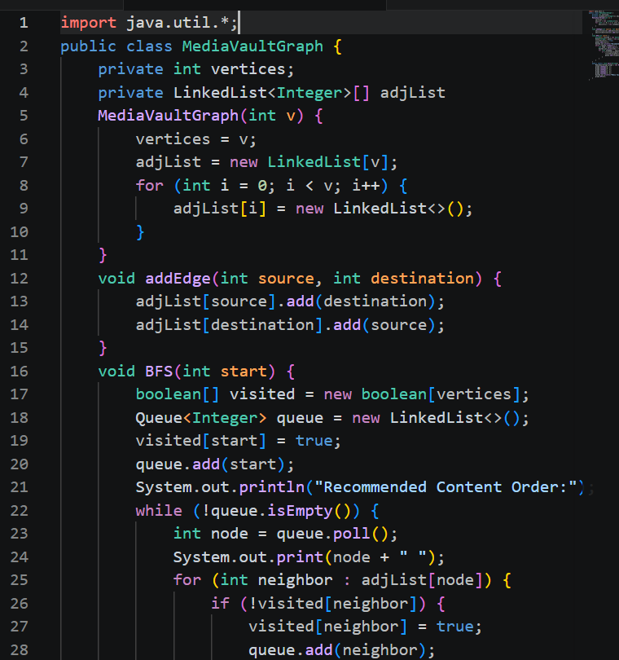
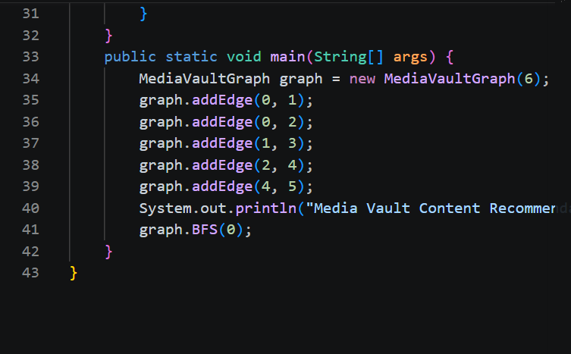

Output:-
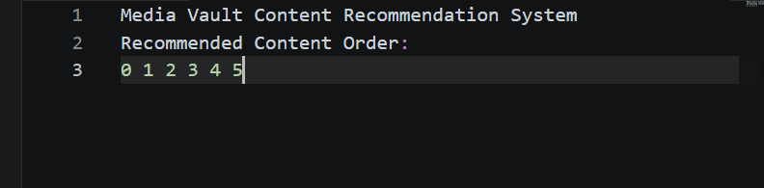
.
The Graph-based recommendation system successfully suggested related content to users. BFS and DFS enabled efficient navigation through content relationships, improving recommendation accuracy and user experience.
GitHub Link: https://github.com/snehiths399-byte/MediaVault--Digital-content-streaming-and-Analytics-system/blob/main/media%20vauly%20graph%20c04
Student Signature Faculty Signature

